Chapter 1

Web Application (In)security:
The Evolution of Web Applications:
Early websites were mostly static and posed little risk, but modern websites function as interactive web applications with two-way data flow. These applications often handle sensitive user and business data, making security critical. When web apps are poorly secured, they create serious risks, as attacks can result in data theft, fraud, and misuse of information.
Common Web Application Functions:
Web applications now support almost every online function, from shopping, banking, social networking, and auctions to email, search, and collaborative information sharing. Beyond the public internet, they are widely used within organizations for business operations, administration, and device management. Many traditional desktop and client-based applications—such as ERP systems, email clients, and office software—have migrated to web-based platforms, making the web browser the primary client for most users.
As this trend continues, a vast range of services relies on shared web technologies, inheriting common and significant security vulnerabilities.
Benefits of Web Application:
Web applications are popular because they use the lightweight HTTP protocol, work on any device with a browser, and require no separate client installation. Modern browsers support rich, user-friendly interfaces, while simple and widely available development tools make web applications easy to build, update, and maintain.
“This Site Is Secure”:
Many websites claim to be secure simply because they use SSL, which protects data in transit and verifies server identity. However, most web applications are still insecure due to flaws unrelated to SSL, such as broken authentication, poor access controls, SQL injection, cross-site scripting, and information leakage. SSL cannot prevent these attacks, which typically target application logic rather than network traffic. While SSL is essential, relying on it alone—or replacing it with proprietary security methods—does not make a web application secure.

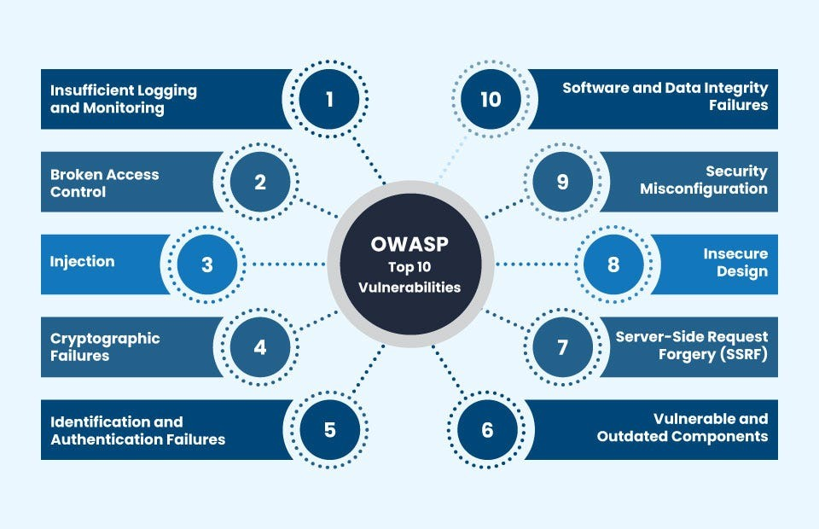

So, what is SSL?
SSL is a network security protocol that ensures confidentiality, integrity, and authentication between a client and a server. It operates between the Application layer (Layer 7) and the Transport layer (Layer 4) in the OSI model.
How SSL Works: When the application layer sends data, SSL encrypts it and adds a secure header before handing it to the transport layer. On the receiving side, the header is removed, the data is decrypted, and then passed up to the application layer securely.
SSL is not a single operation but a suite of protocols working together to ensure secure data transmission. Which protocols?
Key protocols within SSL include:
- Handshake Protocol: Establishes a secure connection, negotiates cryptographic algorithms, and exchanges keys. [important] (it ensures authenticity)
- Record Protocol: Handles data encryption, integrity checks, and secure transmission of messages. [important] (it ensures confidentiality, integrity)
- Alert Protocol: Sends error or warning messages during the session (e.g., handshake failure). (it handles any error messages)
- Change Cipher Spec Protocol: Signals the transition to a newly agreed set of cryptographic parameters. (it changes the pending state to the current state)
How Digital Certificates Work in SSL:
- Certificate Creation by the Server and CA:
- The server generates a public-private key pair.
- It sends its public key and domain name to a Certificate Authority (CA).
- The CA verifies the server’s identity and then creates a digital certificate, which includes the server’s public key and domain name, digitally signed using the CA's private key.
- What’s Inside the Certificate?
- Server’s public key
- Domain name
- Certificate expiration date
- Signature created by the CA: Sign(Hash of certificate info) using CA's private key
- Handshake and Verification by Client:
- The server sends its certificate to the client during the SSL handshake.
- The client already has a list of trusted CA public keys (built into browsers/OS).
- The client uses the CA’s public key to verify the CA’s signature on the certificate.
  - This proves the certificate wasn’t forged or tampered with.
- If valid, the client trusts the server’s public key from the certificate.
- Secure Key Exchange:
- The client then generates a symmetric session key, encrypts it using the server’s public key, and sends it to the server.
- The server decrypts it using its private key. Now both share the same symmetric key.
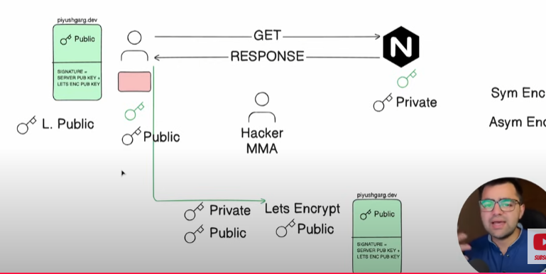

The Core Security Problem: Users Can Submit Arbitrary Input:
The main security challenge in web applications is that all user input is untrusted and may be malicious. Attackers can manipulate requests, bypass client-side controls, and send unexpected or crafted data using custom tools.
Most attacks exploit poorly handled input to alter logic, access data, or inject malicious queries. SSL does not stop these attacks, since it only encrypts data in transit. An application is vulnerable whenever it fails to securely process untrusted input.
Key problem factors:
Web applications must process untrusted input, making them vulnerable to malicious data.
Several technical, organizational, and human factors worsen this security challenge.
Immature Security Awareness: Web application security knowledge is less developed than network or OS security. Many developers lack awareness of basic vulnerabilities and secure coding concepts.
In-House Development: Most web applications are custom-built, making each one unique and error-prone. Unlike standardized products, custom code often introduces unforeseen vulnerabilities.
Deceptive Simplicity: Modern tools allow rapid development of functional applications by inexperienced programmers. However, secure coding requires deeper expertise that many developers lack.
Rapidly Evolving Threat Profile: Web application threats evolve quickly due to ongoing research and innovation. Developers may fall behind current attack techniques before deployment.
Resource and Time Constraints: Limited budgets and tight deadlines reduce focus on security practices. Security testing is often minimal and misses complex or subtle vulnerabilities.
Overextended Technologies: Older web technologies are stretched beyond their original design purposes. This misuse creates unexpected behaviours and introduces new security flaws.
The New Security Perimeter:
Web applications have shifted the traditional security perimeter from network defenses to the application layer itself, as firewalls must allow web traffic and backend connectivity for normal operation. Vulnerabilities in web applications can allow attackers to bypass network controls and directly access critical systems or perform high-value actions such as data theft or financial fraud. Even a single coding flaw can expose an organization’s internal infrastructure.
Additionally, vulnerable web applications can be abused to attack users, including those on trusted internal networks, by exploiting their browsers without their knowledge. As a result, application owners now bear a critical responsibility to implement strong security controls within the application to protect both backend systems and users.
The Future of Web Application Security:
Web application security remains weak due to persistent vulnerabilities and limited industry maturity, with little sign of the core problem factors disappearing soon. While common flaws like SQL injection are declining and becoming harder to exploit, attackers are increasingly focusing on subtle and advanced vulnerabilities. Security research is also shifting from server-side attacks to user-targeted attacks that exploit application flaws through user interaction. As server-side defenses improve, the client side has become the primary battleground and the fastest-evolving area of web application security.

Summary,
- Modern websites are interactive web applications that handle sensitive data, making security critical.
- Poorly secured web applications can lead to data theft, fraud, and misuse of information.
- Web applications power most online and enterprise services and have replaced many desktop applications.
- Shared web technologies mean shared and widespread security vulnerabilities.
- Web applications are popular due to browser-based access, no client installation, and easy development.
- Using SSL/HTTPS alone does not make a web application secure.
- SSL only protects data in transit and verifies server identity, not application logic.
- Common vulnerabilities include SQL injection, XSS, broken authentication, and access control flaws.
- SSL operates between the application and transport layers of the OSI model.
- SSL uses multiple protocols:
- Handshake: authentication and key exchange
- Record: encryption and integrity
- Alert: error handling
- Change Cipher Spec: activates new cryptographic settings
- Digital certificates verify server identity using trusted Certificate Authorities (CAs).
- SSL establishes a shared symmetric session key for secure communication.
- The core web security problem: all user input is untrusted and can be malicious.
- Attackers can bypass client-side controls and manipulate requests.
- SSL cannot stop attacks that exploit poor input handling.
- Web application insecurity is worsened by:
- Low developer security awareness
- Custom in-house development
- Overly simple development tools
- Rapidly evolving attack techniques
- Limited time and security resources
- Misuse of older web technologies

- Web applications are the new security perimeter, not the network.
- A single application flaw can expose internal systems and users.
- Vulnerable applications can be used to attack users via their browsers.
- Web application security remains weak and immature.
- Attackers are shifting toward subtle, advanced, and client-side attacks.
- The client side is now the primary and fastest-evolving security battleground.

--The End--

